Proposed System Architecture & Technical Design Document

Proposed System Architecture

1.1 High-Level Architecture Diagram
Proposed System Architecture Diagram is as follows:
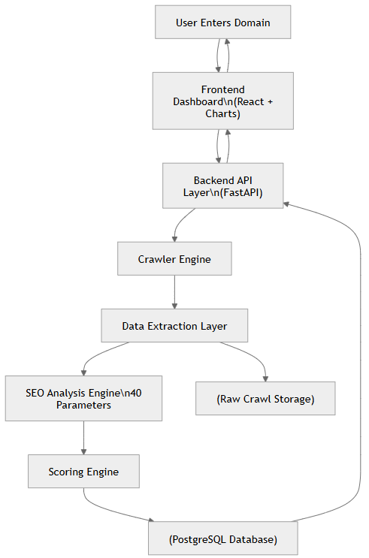

1.2 SEO Analysis Engine Structure
The SEO Analysis Engine follows a strict 5-layer evaluation model:
Proposed SEO Layer Breakdown Diagram is as follows:
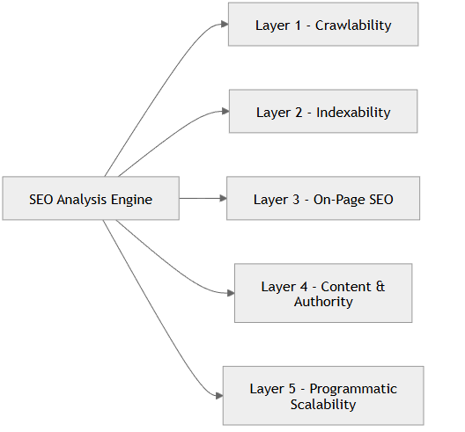

1.3 Processing Lifecycle Flow
Proposed Processing Lifecycle Diagram is as follows:
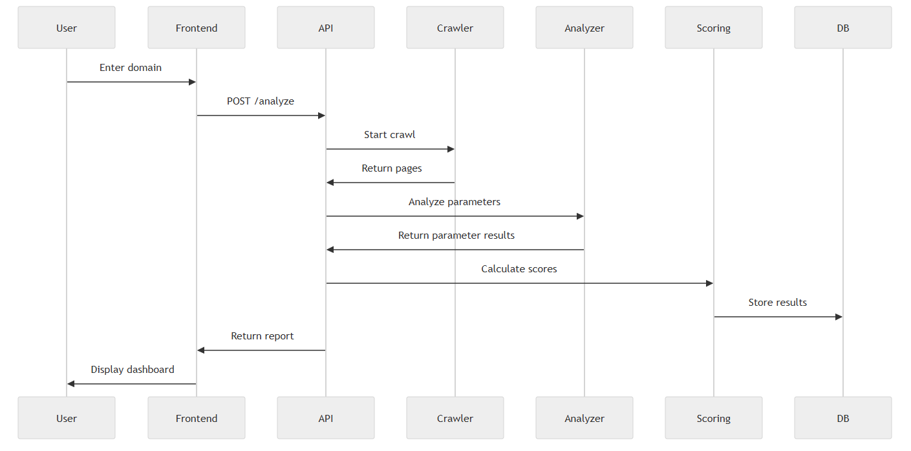
Full Product LifeCycle :
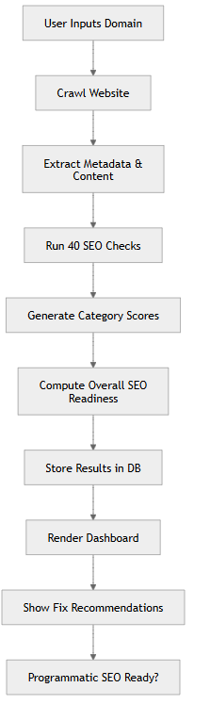

1.4 Database Schema Design
The database is structured to store:
- Website-level data
- Page-level crawl data
- Parameter-level evaluations
- Category-level scores
- Overall readiness score
Proposed Database Schema Diagram is as follows:
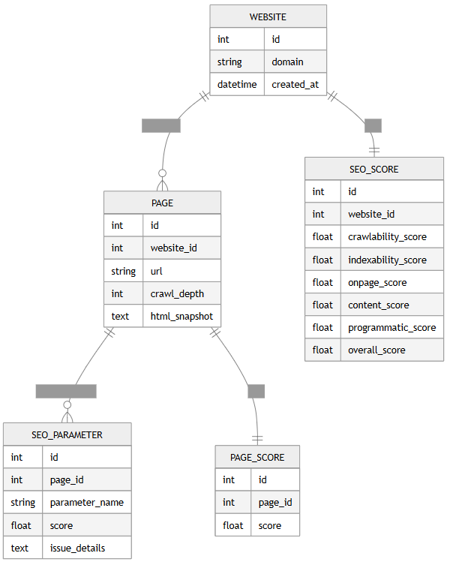

2. Proposed Technical Stack

2.1 Backend Stack
Proposed Backend Technology Stack:
Runtime: Node.js (v20+)
Framework: Express.js
Crawling: Axios + Cheerio
Queue (Phase 2): BullMQ + Redis
Graph analysis: graphlib
Validation: Joi / Zod
ORM: Prisma
Async processing: Native async/await

2.2 Database Stack
Proposed Database Configuration:
Primary DB: PostgreSQL
ORM: Prisma
Cloud Free Option: Supabase / Neon

2.3 Frontend Stack
Proposed Frontend Technology Stack:
Framework: React (Vite)
Styling: Tailwind CSS
Charts: Chart.js
HTTP Client: Axios

2.4 Infrastructure & Deployment
Proposed Infrastructure & Hosting Strategy:
Backend Hosting: Render / Railway
Frontend Hosting: Vercel
DB Hosting: Supabase
3. Proposed GitHub Repository Structure
Proposed GitHub Structure is as follows:
psra/
│
├── backend/
│ ├── src/
│ │ ├── server.js
│ │ │
│ │ ├── routes/
│ │ │ └── analyze.routes.js
│ │ ├── controllers/
│ │ │ └── analyze.controller.js
│ │ ├── crawler/
│ │ │ └── crawler.engine.js
│ │ ├── extractor/
│ │ │ └── content.extractor.js
│ │ ├── analyzer/
│ │ │ ├── crawlability.js
│ │ │ ├── indexability.js
│ │ │ ├── onpage.js
│ │ │ ├── contentAuthority.js
│ │ │ └── programmatic.js
│ │ ├── scoring/
│ │ │ └── scoring.engine.js
│ │ ├── services/
│ │ │ └── seo.service.js
│ │ ├── prisma/
│ │ │ └── schema.prisma
│ │ └── utils/
│ │ └── helpers.js
│ ├── package.json
│ └── .env
├── frontend/
│ ├── src/
│ │ ├── components/
│ │ ├── pages/
│ │ ├── services/
│ │ └── App.jsx
│ ├── package.json
│ └── vite.config.js
├── docs/
│ ├── architecture.mmd
│ ├── lifecycle.mmd
│ ├── database_design.mmd
│ └── system_overview.docx
├── README.md
└── docker-compose.yml (Phase 2)

4. Development Roadmap

Phase 1 – Core Engine (MVP Foundation)
Objective: Establish the base crawling and scoring pipeline.
Scope:
- Implement website crawling engine
- Extract core metadata and content
- Evaluate initial set of 5 critical SEO parameters
- Develop basic scoring logic
- Expose working API endpoint for analysis
Deliverable:
Functional backend capable of analyzing a domain and returning structured SEO results.

Phase 2 – Complete SEO Analysis Engine
Objective: Expand evaluation coverage and introduce persistence.
Scope:
- Implement full 40-parameter evaluation model
- Integrate PostgreSQL database
- Enable asynchronous crawling for performance
- Build internal link graph analysis
- Store page-level and category-level scores
Deliverable:
Fully operational SEO readiness engine aligned with PRD evaluation layers.

Phase 3 – Dashboard & Optimization
Objective: Build user-facing reporting interface and optimize performance.
Scope:
- Develop interactive reporting dashboard
- Implement category-level visualizations
- Improve crawl efficiency and concurrency
- Optimize scoring and database performance
Deliverable:
End-to-end system with visual reporting and scalable architecture.

